Reading with Expression

RF.2.4.b. Read on-level text orally with accuracy, appropriate rate, and expression on successive readings.

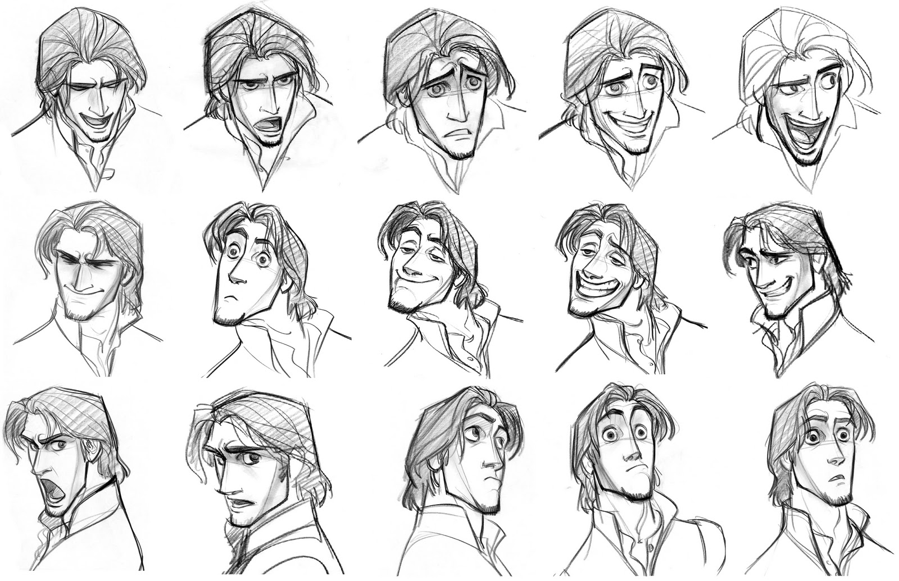Materials: Cowgirl Kate and Cocoa, PPT, whisper phones

**A**- Look at a sketch of various expressions of a Disney character-

"What do you notice about this series of drawings?"

**G**- I can read with expression

**N-** When you read with expression, you change your voice to

match the character's feelings- Model with chapter 1

**A**- Practice reading with expression- read chapter 2

**G**- I can read with expression